**CookBook: Your Virtual Kitchen Assistant**

**Ideation Phase**

**Brainstorm & Idea Prioritization**

|  |  |
| --- | --- |
| Date | 31 January 2025 |
| Team ID | SWTID1741257978145975 |
| Project Name | COOK BOOK |
| Maximum Marks | 4 Marks |

**Step-1: Brainstorm, Idea Listing and Grouping**

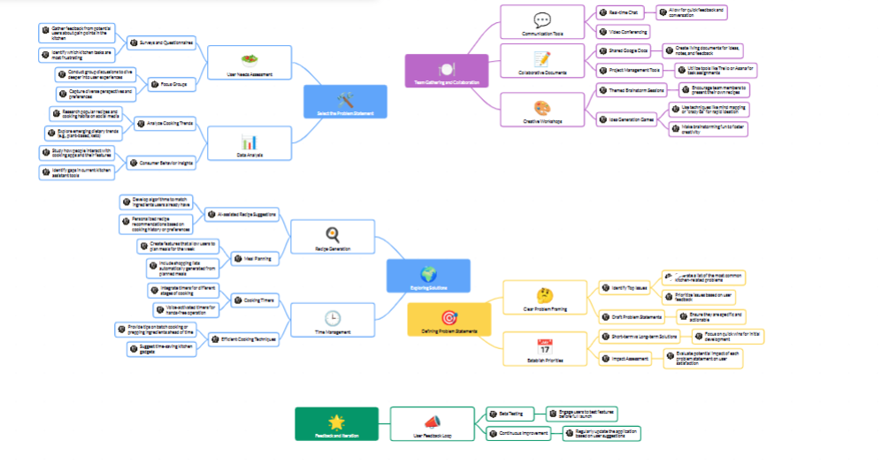

**Introduction**

The ideation phase of any project is crucial as it sets the foundation for the entire development process. In the case of *CookBook: Your Virtual Kitchen Assistant*, this phase involves gathering the team, collaborating on ideas, and selecting a clear problem statement that aligns with our goal of revolutionizing the cooking experience. In this phase, we will work together to identify user needs, potential challenges, and the best solution to address them.

**1. Team Gathering**

The first step in the ideation phase is assembling a talented team with diverse expertise. For *CookBook: Your Virtual Kitchen Assistant*, our team will consist of:

* **Product Managers** who understand the market and user needs.
* **Designers** who will focus on creating intuitive user interfaces and seamless experiences.
* **Developers** who will ensure the technical feasibility and implementation of the assistant.
* **Chefs & Culinary Experts** who can bring a real-world perspective on kitchen dynamics.
* **Data Scientists/AI Engineers** to work on the core AI algorithms that power the virtual assistant.

The collaboration of individuals from different backgrounds will ensure that all angles of the project are considered, from user experience to technical challenges.

**2. Collaboration Process**

Collaboration is key to successful ideation. Here are the steps we’ll take to brainstorm, discuss, and finalize our ideas:

* **Initial Brainstorming:** In this session, everyone contributes their ideas for features and capabilities of the virtual kitchen assistant. This could include recipe suggestions, ingredient substitutions, time-saving tips, or voice control features.
* **User-Centered Approach:** We will keep the users at the heart of all discussions, considering pain points and daily challenges faced in the kitchen. This ensures that our virtual assistant addresses real problems.
* **Research and Inspiration:** To fuel creativity, we will look into existing solutions and competitors in the market. We’ll also analyze user feedback on platforms like forums or surveys to understand the most pressing kitchen-related issues.
* **Prioritization:** Once ideas are collected, we’ll prioritize features based on feasibility, impact, and relevance to users. This will help us focus on creating the most impactful solution first.

**3. Selecting the Problem Statement**

After collaborating, it’s time to zero in on a clear and concise problem statement. A strong problem statement is essential as it drives the development of features and sets the direction for the entire project. Some potential problem statements for *CookBook: Your Virtual Kitchen Assistant* could include:

1. **“How can we simplify meal preparation for busy individuals who struggle to plan meals with limited ingredients and time?”**
   * Focus: Time management, ingredient planning, easy-to-follow recipes.
2. **“How can we create a virtual assistant that helps users navigate the complexity of meal preparation while offering dietary customization?”**
   * Focus: Personalization, dietary preferences, health-conscious cooking.
3. **“How can we minimize food waste by suggesting recipes based on the ingredients available in the user's kitchen?”**
   * Focus: Sustainability, ingredient utilization, reducing waste.
4. **“How can we make cooking more accessible to beginners by offering intuitive instructions, real-time assistance, and personalized advice?”**
   * Focus: User education, step-by-step guidance, ease of use.

The selected problem statement will guide the scope of our solution and ensure that we’re solving a meaningful and relevant challenge for our target audience.

**4. Next Steps**

Once the problem statement is finalized, the team will move forward with:

* **User Persona Development** to understand the characteristics of our target users.
* **Feature Mapping** to identify the most important functionalities of the virtual assistant.
* **Prototyping** and testing to validate the concepts before development begins.

**Conclusion**

The ideation phase is where creativity meets practicality. By bringing together a diverse team, collaborating effectively, and selecting a focused problem statement, *CookBook: Your Virtual Kitchen Assistant* will be well-positioned to solve real kitchen challenges and enhance the cooking experience for all users.